**Tutorial for Plotting Figures (pl_aac)**

By Armen Bagdasarov (Duke University)

Create New Protocol

File 🡪 New protocol

Create

Change Anatomy to desired template (12-month infant in the below case)

Click Yes on warnings that pops up to replace the default anatomy

*** Unfortunately, Brainstorm only has templates for infants and adults, so if you want a template for children, for example 4-year-olds, you will have to do the surface extraction yourself. This will involve finding a template MRI, creating the surface models in FreeSurfer yourself, and importing them into Brainstorm. It may be helpful to see how the O’Reilly models were created: <https://doi.org/10.1016/j.neuroimage.2020.117682> ***

Downsample Cortex

Enter 4997 to get 5000 vertices

*** You might need to play around with the numbers depending on what you need

OK

OK

This last step makes sure that all vertices are inside the skull, which is very important

Add Subject

File 🡪 New subject 🡪 Save

Switch to Functional data view

Change Electrode Cap

It is extremely important to select the right cap AND to make sure the MRI registration is good

Check MRI Registration

Are the electrodes glued to the brain? If they are not, and they are floating, this is bad! You have either selected the wrong channel file or you must edit the positions yourself.

For example, if we had selected Add EEG positions 🡪 NotAligned 🡪 EGI 🡪 GSN Hydrocel 128 E001, then our electrodes would be floating like this:

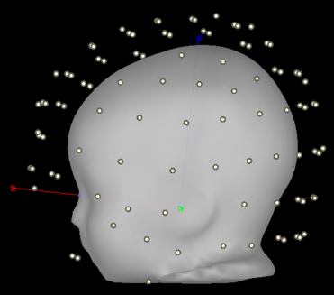

This is bad!

We want it to look like this:

Import Subject’s Data

Find and select EEG file, click Import

Add Noise Modeling as Identity Matrix (no noise modeling, we do not need this for EEG)

Compute Head Model

OK

OK

Will take a while depending on your computer, but hopefully not too long (about 15-30 minutes on an average computer)

Compute Sources

*** For plotting figures, we should select Constrained for the Dipole Orientations. We will use Unconstrained + PCA of the EEG data for computing the actual imaging kernel. ***

Working with the Computed Sources

Enter name for variable: kernels_12m_figure (or whatever you would like)

OK

Go to Matlab Workspace and Save As to save Matlab variable on computer for later use if you want

Open the Matlab variable (kernels_12m_figure or whatever you called it) and you will see that it contains ImageGridAmp. This is what you use to plot. It contains a column vector for each vertex in the brain.

In the Matlab command window, type (adjust code depending on what you called the kernel and how many vertices you have):



Now import this into Brainstorm

OK

Display Source Activations on Cortex

Change Surface and Data Options

We get this, which is a random distribution of values on the cortex.

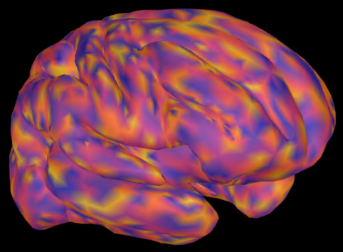

One nice way to look at different views is to click the Struct button

It splits the brain into right and left hemispheres

Right click 🡪 Figure 🡪 Clone Figure

Now we can rotate the figures to see both sides at the same time, which is helpful especially if the main activity is lateral or medial

High-Resolution Figures

When publishing an actual figure, we’d want to get a high-resolution image

As an example: Go to Scout 🡪 Click on random scout by pressing the plus button and then clicking anywhere on the brain. So now we have a scout.

Then we project it back onto the high-resolution cortex (select the cortex with the large number of vertices)

Go to Anatomy view

Here you will see this tess2tess_interp:



This is high-resolution vertices X column vector

Enter a name for the variable: kernels_12m_figure_high_resolution (or whatever you’d like)

In the Matlab command window, type (adjust accordingly to your variable names):

We get a ~141,484 column vector

Now we need to create an artificial brain to plot in high-resolution space

File 🡪 New Subject 🡪 Save

Set the high-resolution cortex as the default (in Anatomy view)

Now do everything as you did before to plot the brain, but here’s the important part: DO NOT use OpenMEEG BEM when computing the head model. Use the 3-shell model. We don’t care about the accuracy of it, we just need a brain to plot on.